School of Engineering

Christian Brothers University

Invoice & Inventory Management System

The Engineering Management Capstone Project

Submitted in Partial Fulfillment for the Degree of Master of Science in Computer Information Systems

By:

**Mohammed Yaqoob**

**Bala Rama Krishna Peddi**

Memphis, Tennessee

April 21, 2023

# Abstract

The objective of this project is to develop a simple and easy web application that helps any stock-based organizations such as warehouses, Gas stations wholesalers, etc. to maintain their Invoices and manage the stock properly, by Using Java and SQL technologies to manage and create their inventory system, we named this application as Invoice & inventory management System. This software provides complete control of any invoices, like updating & viewing to run the business smoothly & efficiently. Without proper inventory control, a company may run out of stock of important products. A good software system will alert a company when it’s running out of stock. An automated invoice & inventory management system software helps to minimize the problems in running the business.

# RACI CHART:

It’s a simple tool that identifies roles and responsibilities against tasks within a capstone project. It follows 4 basic rules to get the work done, it simply allows us to divide the responsibilities so that the project can be done within a given period. The RACI chart is described as:

R = Responsible – those who do the work to complete the task

A = Accountable – one person answerable for completion of the task (approves R’s work)

C = Consulted – Look for the opinions, Such as subject matter experts (SMEs)

I = Informed – Those to keep up-to-date.

|  |  |  |  |
| --- | --- | --- | --- |
| **Index** | **Tasks** | **Rama Krishna** | **Mohammed Yaqoob** |
|  | **Invoice and Inventory Management** | **Role** | **Role** |
| **1.0** | **Capstone Project Registration** |  |  |
| 1.1 | Submit proposal | R | R |
| 1.2 | Topical approval | R | R |
| 1.3 | Course Registration | R | R |
| **2.0** | **Orientation** |  |  |
| 2.1 | Attend Orientation class |  | R |
| 2.2 | Complete Orientations class | R | R |
| 2.3 | Read all canvas Information | R | R |
| **3.0** | **Assignments** |  |  |
| 3.1 | Final proposal | R | A |
| 3.2 | Complete outline | A | R |
| 3.3 | Weekly status | A | R |
| 3.4 | Interm report | R | A |
| 3.5 | final report | A | R |
| 3.6 | Final presentation | R | R |
| 3.7 | Oral Presentation | R | R |
| **4.0** | **Development** |  |  |
| 4.1 | Authentication page | A | R |
| 4.2 | Navbar for admin user | C | R |
| 4.3 | Login for admin | R | C |
| 4.4 | Logout Functionality | C | R |
| 4.5 | Registration Page for users | R | A |
| 4.6 | Login for Users | A | R |
| 4.7 | View the profile of the user | A | R |
| 4.8 | Change the password for the user | R | R |
| 4.9 | Logout Functionality for User | A | R |
| **5.0** | **User and admin Functionality** |  |  |
| 5.1 | Add product from | R | A |
| 5.2 | Accept user request by admin when created user | A | R |
| 5.3 | Contact Us page on the cover page | A | R |
| 5.4 | About us Page on a cover page | R | A |
| 5.5 | Adding stock | A | R |
| 5.6 | Viewing Stock | R | A |
| 5.7 | Generating Invoices | A | R |
| **6.0** | **Documentation** |  |  |
| 6.1 | The idea of the project | A | R |
| 6.2 | Research on project | A | R |
| 6.3 | Making draft paper | A | R |
| 6.4 | Submitting draft paper | R | R |
| 6.5 | Interm report | R | R |
| 6.6 | Writing and communication center(appointment) | R | R |
| 6.7 | Making documentation | A | R |
| 6.8 | Finalizing Documentation | A | R |
| 6.9 | Making PPT | R | R |
| **7.0** | **Oral Presentation** | R | R |

# Table of contents: Page No:

1. Introduction…………………………………………………………………...6
2. Objectives…………………………………………………………………….7
3. Problem Statements…………………………………………………………7
4. Business Analysis……………………………………………………………9
5. Tools and Technologies…………………………………………………….9
6. Software Design………………………………………...…………………...11

6.1. Software process chart………………………………………………...11

**7)** Methodology (Research)…………………………………………………...12

**8)** Features of the project…………………………………...………………...14

8.1) Cover page……….………………………………………………………14

8.2) Admin form……………………………………………………………….15

8.3) User form…………………………………………………………………18

**9)** Data analysis……………………………………………...………………...19

**10)** Conclusion…………………………………………………...………………22

**11)** Future Improvements……………………………………………………….23

**12)** References…………………………………………..………………………23

**13)** Appendix……………………………………………..………………………24

* 1. ) Appendix A: List of Figures………………………………………………24
  2. ) Appendix B: List of Abbreviations……………………………………….24

# 1) INTRODUCTION:

In daily life, computers are one of the basic needs for any small or large-scale organization to run a business or perform any useful activity. Technologies help the business or any field of the organization to grow very vast and drastically, it helps them in business, billing, generating invoices, and money transfers online from one place to another, and many activities with the help of computers. Computers are also used for controlling the inventory management system with the help of technology. As MSCIS students were familiar with the Invoice & inventory management system (IIMS) through our experience we came up with an issue with small-scale business organizations that some organizations don’t have enough funds to develop their software system and couldn’t maintain a proper inventory of their available stock and having an issue to maintain their inventory.

The present software is Artificial Intelligence (AI) and the rapidly growing tools for solving complicated ideas. In small-scale organizations, most organization don’t use software, or some organization runs the system manually, but using software gas station, warehouses, and convenience store can maintain their products and goods information and runs the business without difficulty.

IIMS control system has been designed to aid small-scale business organizations in maintaining their day-to-day sales activities that organization making it.

Through this IIMS software can provide daily, monthly, or annual basis reports and particular Invoices or hard copies for an organization.

The Invoice and Inventory Management System project is a fully functional desktop application created with Java Technology and Eclipse IDE. The project’s primary goal is to create a software model for an invoice and inventory management system that contains all the organization's stock information.

The secondary goal is to develop software that deals with the daily requirements of any business organization. This desktop program is built around managing an organization's stock. Generating the organization’s profiles, sales, and purchase information, and the organization's livestock is included in this application. It is possible to update the inventory as well.

# 2) OBJECTIVES:

The main objective of this application is to create an environment that helps small-scale business organizations maintain and handle their business such as sales, purchases, and remaining products to make sure the stock is available, to improve and run a business without any hurdles to maximize the profit of the organization. This current project is to design a computerized desktop for a sales system. The system managed all invoices of different companies and different departments as per the requirements of the organization. This system makes business easy to handle and gets particular invoices and customer information according to client and department id. We can find out how many particular products are present in the product table and also know if the particular current product is less than the requirement it creates an alert message of that product. In the user form, we have a search option according to the invoice, that helps us to find out which date the invoice is created. Every form has the necessary buttons, which help us to record and add products. Every form stores its information record in the database once we create the form it automatically saves the information in a database.

# 3) PROBLEM STATEMENTS:

As we go through different convenience stores or gas stations we see that their products have not been organized and the store room is full of mess and is maintained improperly as we see in Fig 3.1 that the gas station store room is running out of space and the products are also not managed and not stocked properly, so we came across with the issue that the store couldn’t manage their inventory and every other day new companies are ordering new stuff from which the old stock is leaving behind moreover the products are also misplaced and combined the American and Spanish products and some of the products are out of stock and some are full of stock that they don’t even require. And to do all that work is a time-consuming process, which we eliminate here with our IIMS software. We will add functionality to search for a particular product in the application and check how much of the stock is available in our inventory. This product saves time for both customer and the salesman. This kind of problem generally occurs in small-scale business organizations. Large-scale business organizations properly maintain the inventory, so they don’t get into these problems. So, our application is mainly focused on small-scale organizations. Good software helps the organization to maintain and run the business smoothly.

**Fig 3.1: Storeroom of the gas station**

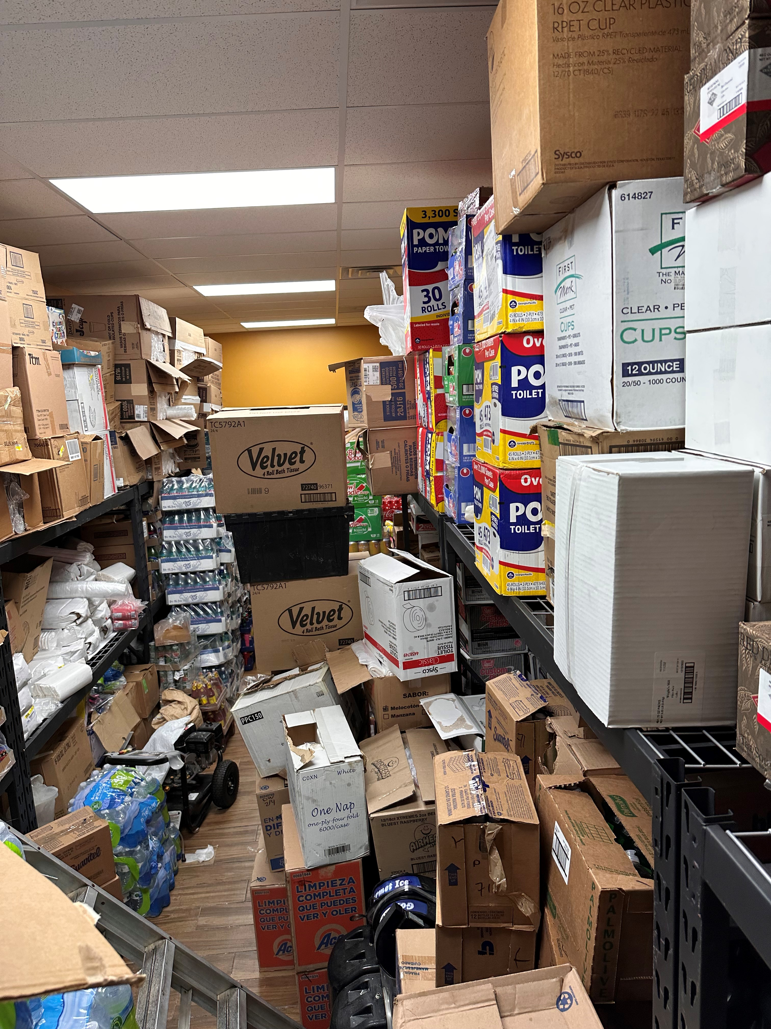

# 4) BUSINESS ANALYSIS:

Invoice and Inventory Management helps the business to grow and gives the company a competitive edge, and the business functions can be controlled properly in a sequenced manner, it produces short information about a business’s current news and inventory levels as of the data entered, so to be aware of the total sales and dates of transactions that occurred and distributed on a given period. In specific information on the selling and purchasing of the goods.

# 5)TOOLS AND TECHNOLOGIES:

In this application, we are using JAVA language for business logic. We have used HTML, CSS, and JAVASCRIPT languages for front-end development. And we have used the MYSQL database for the storage of the data of this application. We have used the above-mentioned tools for the development of this application.

* MySQL workbench 8.0CE
* Eclipse IDE for java Devlopers-2022-12
* Jdk 7u21-windows-x64.exe
* Java Jit compiler
* HTML (hypertext markup language)

MySQL is a set of instructions used for storing, manipulating, and retrieving data in the database. We used RDBMS in MySQL for good communication and interaction for the application.

Furthermore, for visuals, we used Eclipse IDE for Java Developers-2022-12 its free of cost and highly recommended for Java developers. It helps to create an environment for Java in which all the Java coding is done and saved as folders and files that can be easily accessed and run in the real world. And it provides tools for Java environment, editors, wizards, builders, and code merging and refactoring can be done.

**TECHNOLOGIES WE USED IN THIS APPLICATION.**

**1.** HTML

**2.** CSS

**3.** JavaScript

**4.** Java

**5.** MySQL

**1. HTML:** HTML is used for the Frontend part of our project. With the HTML tags, we are defining the content, headings, and titles and creating forms for the login page, registration page, and other forms of the project.

**2. CSS:** CSS is used to design our application. We have used it to add styles and colors to our project like font size, font family, font colors, and background colors, and to add the margins, spacing, and padding wherever required.

**3. JavaScript:** JavaScript is a client-side scripting language. We have used JavaScript for giving dynamic effects to our application. We validate forms like login pages, registration pages, and other forms using JavaScript. It is also used to give alerts if data is entered incorrectly. If we are leaving a field empty in the form which is necessary to fill, and the user is not filling the field and clicking on submit it will give the alert to fill the form.

**4. Java:** We have used Java language to write the logic of our application. We have used JSP (Java Server Pages where we can design our application and write the logic of our application on the same page. In the JSP page, we can use HTML tags, CSS attributes, and scripting language and if we want to write the logic in Java language, we can use <% %> these libraries, and between these libraries, we can write the Java code. And also, used JDBC (Java Database Connectivity) which will connect our application to the MySQL database server.

**5. MySQL database:** With the use of MySQL, we are creating the tables of our application where we can store the data of our application. Suppose we have no. of products in our application, to store the details of each product we have created a table called products in the database of our application. Likewise, we have created other tables to store the data regarding different functionalities.

# 6) SOFTWARE DESIGN:

Software design lifecycle is also referred to as a system study. The system analyst gives a system complete meaning and direction of the project life cycle.

# 6.1. SOFTWARE PROCESS FLOW CHART:

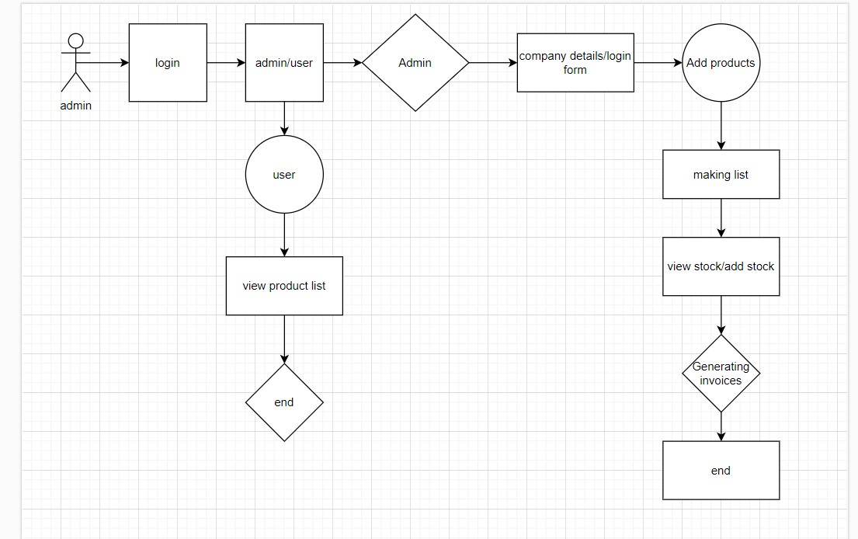

**Fig 6.2 IIMS Process flow diagram**

# 7) METHODOLOGY(RESEARCH):

Inventory management technology helps you track and manage inventory orders, their use and storage, and control the products that are available for sale. Improper inventory management can increase inventory costs, lack of working capital, wasted labor, increased idle time, disruptions to the supply chain, and more.

In Inventory management, there isn’t everything fits all methodology, every business methodology is different from the other’s business methodology & Ideology as the large-scale industry and small-scale industry both have different thoughts and different methodologies. All these lead to lost sales and dissatisfied customers. Inventory management is therefore an important aspect of a business that management cannot ignore.

Like in small-scale business methodologies requirements, we made the project, they need.

1. **They want to stock less.**

Let’s take an example of a gas station where we can find different items and different products, they don’t bring everything at once, it takes weeks and months to study the customer’s requirements and then they add those products to their inventory based on the customer’s demand.

1. **They want to spend less.**

In small-scale business sectors, they go step by step, for example from grocery stores to convenience stores, and gas stations where they want to invest less and make more profit out of that product which is what their ideology is. The Invoice and inventory management helps them maintain their stocks properly with less efficient money instead of stocking expensive items in less demand based on the customer inflow.

1. **In final, they want to make more money.**

With less maintenance, they make more money, and the business grows efficiently and effectively with the help of this software which is, Invoice and Inventory management system.

1. **In less time.**

Time consumption is a major part of the organization's business breakdown or less profit. With the help of proper Invoice and inventory management, they can minimize the time and cost reduction for employers.

1. **Less risk.**

Protecting and controlling the inventory stored in our application warehouse and every other stock location and doing everything possible to minimize the cost of filling orders.

1. Restocking our stock inventory with the right quantity and item at the right time leads to effective maintenance. Below are the techniques that help in tracking and controlling the inventory.
2. Collect data.
3. Build ID method.
4. Choose a system.
5. Inventory control
6. Utilize software.

# 8) FEATURES OF THE PROJECT:

We gathered the information and designed a simple application that covers the requirements of a project with the help of tools and technologies which we discussed earlier above,

below are the features of the Invoice and Inventory Management system:

**8.1): COVER PAGE:**

We have added a navigation bar on our project's cover page. In this navigation bar, we can access the home page, Login page, User Registration page, Contact us page, and About us Page. It’s simple and easy to access. If we log in with user access it takes us to a different page and if we log in with Admin access it takes us to a different access page, we can see the cover page.

**i. Home Page:** As for now we haven’t added anything to the home page, In the future, we may add functionalities based on our project requirements. As we see in Fig 8.1.

**ii. Login Page:** On this login page we can log in with admin credentials by selecting admin or other user credentials by selecting users. Fig 8.1

**iii. User’s Registration Page:** On this page, we have added a registration form where a user can register by filling in the form. Fig 8.1

**iv. Contact Us page:** This page contains information about contacting us. We have added the address, contact numbers, email IDs and address location map. Fig 8.1

**v. About Us page:** We have added information about the project’s members on this page. Fig 8.1

**Fig 8.1: Home & Navigation bar cover page.**

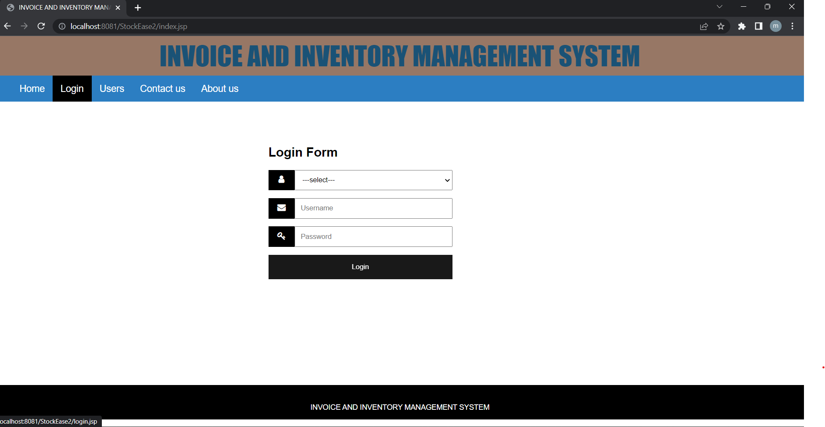

# 8.2) ADMIN FORM:

**i. View users:** On this page, we can accept the request form of the user when a user registers from the registration page by filling up the form as shown below. As we see in Fig 8.2.

**ii. Add products:** In this functionality, we have added a form to add products. By filling out the form with the necessary details we can add products to the inventory.

As we see in Fig 8.3.

**iii. Product list**: This option allows us to view the list of products added to the inventory. As we see in Fig 8.5.

**iv. Add stock:** This functionality is added to add the quantity of a particular product to the inventory. As the stock arrives, we can add the quantity of each product with this functionality. As we see in Fig 8.4.

**v. View stock:** This option allows us to view how much stock is available in the store. As we see in Fig 8.4.

**vi. logout Functionality:** with the logout, functionality admin can log out from the user. As we see in Fig 8.5.

**Fig 8.2: Users sign in form.**

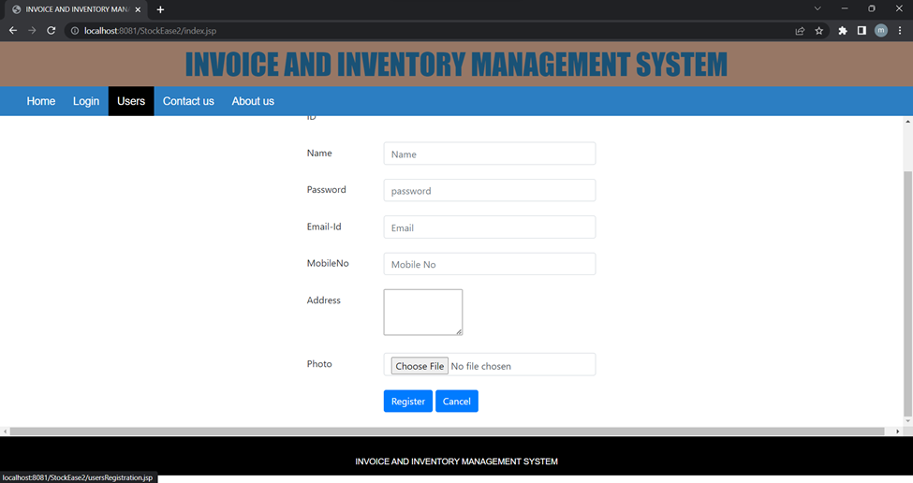

**Fig 8.3: Add product details.**

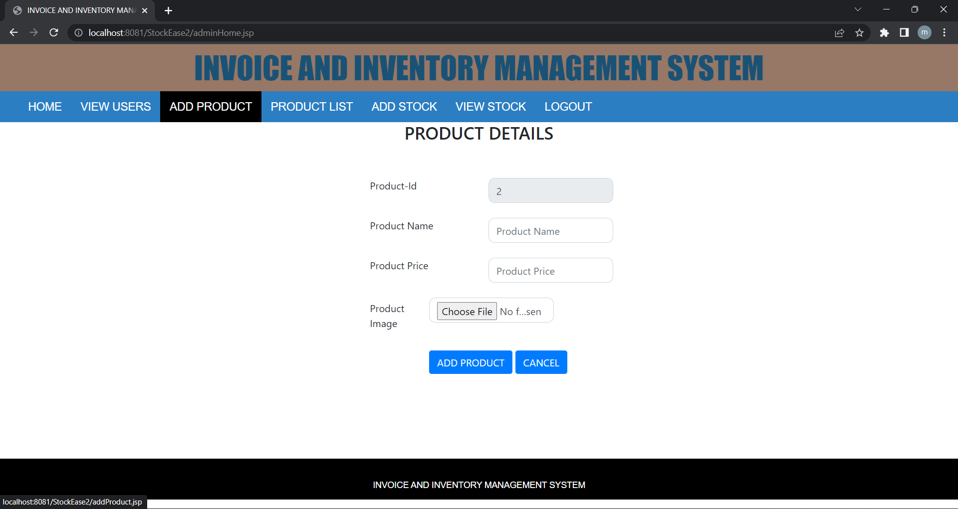

**Fig 8.4: Add stock details.**

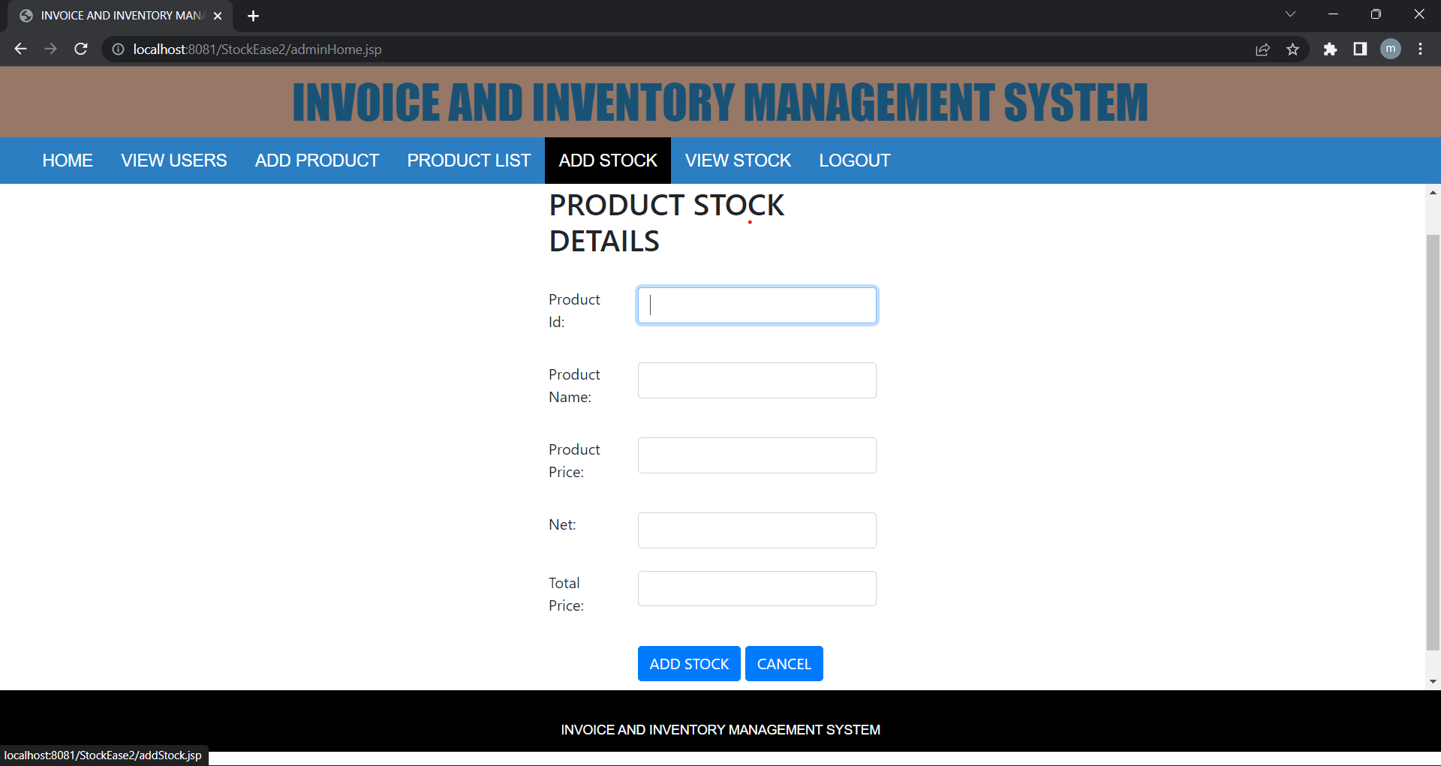

**Fig 8.5: View product list.**

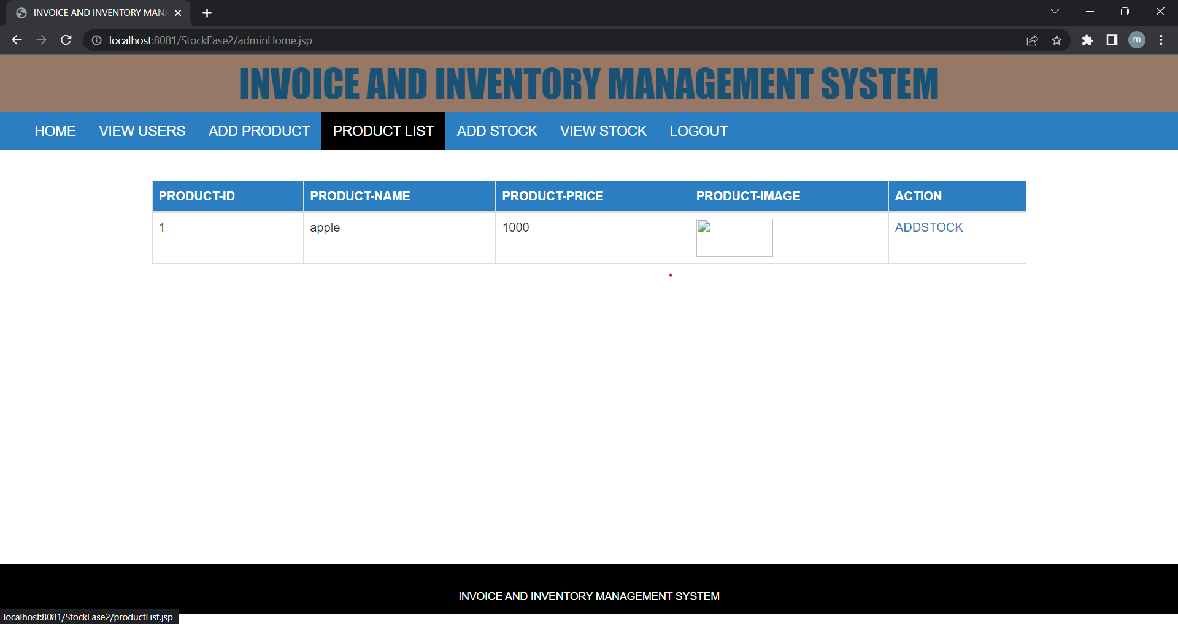

**8.3): USER FORM:**

**i. View Profile:** In this functionality, the user can view the profile himself or the organization for whom he is working. This is just to view the user profile.

**ii. Change Password:** In this functionality, we can change the password for the user. We can see the screenshot of the changes in password functionality. As we see in Fig 8.3.1.

**iii. logout Functionality**: with this functionality, we can log out from the user. As we see in Fig 8.3.1.

**Fig 8.3.1: User/Admin change password.**

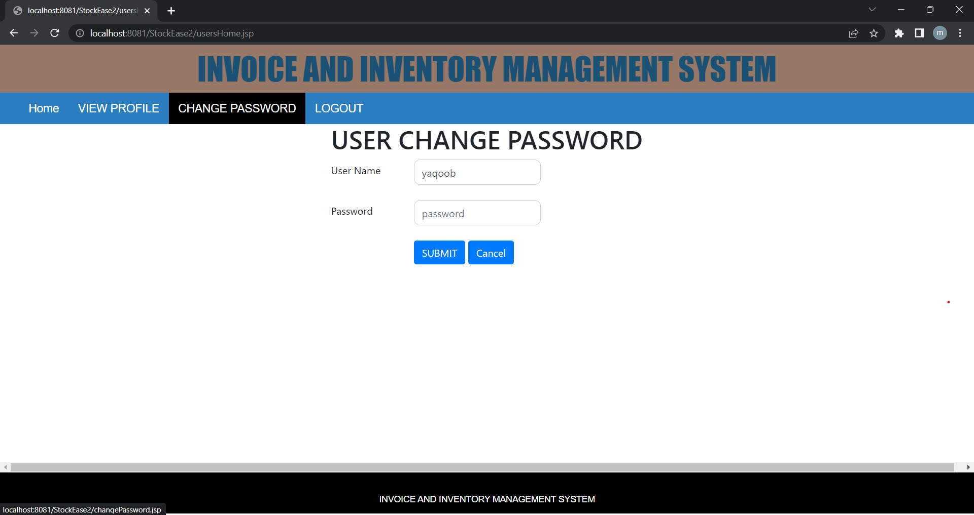

# 9) DATA ANALYSIS:

We start our journey from the surrounding local gas stations of our locality, we observed that they are not maintaining their storerooms in which all the stock has been misplaced, and improperly organized, we also see that some products they have out of stock and some of the products are in excess which is almost about to expire, which is not good for small scale business. It seems that their Inventory is not managed properly, however, we came up with an idea to build an application that helps them to analyze and keep the inventory properly.

With this application, we can thoroughly view our inventory stock and translate the raw data from different sources into meaningful information which helps us to proceed with a project that is suitable for small organizations. And keep the stock properly and in an organized manner. Below is a picture of a gas station that is filled with unnecessary stock that has been ordered without analyzing the livestock and the customer demand, firstly it’s a waste of money, and it takes too much space which we can utilize for other important stock which is more in demand through which we can make good money, and hence some products may run out of date and still occupies the space of a gas station.

The Invoice & Inventory Management System comes into action and tries to help figure out the solution for that problem. So that they can fix their stock and manage them properly.

As we see, IN Fig 9.1 due to improper maintenance of the stock the gas station is facing some issues selling it before it gets expired. The below picture we took with the permission of the owner of a gas station on 3/19/2023. Every month out of 100% of their stock 20% to 25% goes to credit and for some products, the companies don’t provide any credit eventually the owner is at loss at some point. In case the owner manages to maintain proper Inventory, he would have saved money and space for other stock required by the organization.

**Fig 9.1: Gas station stock excess Gummies, Candies, and cigars.**

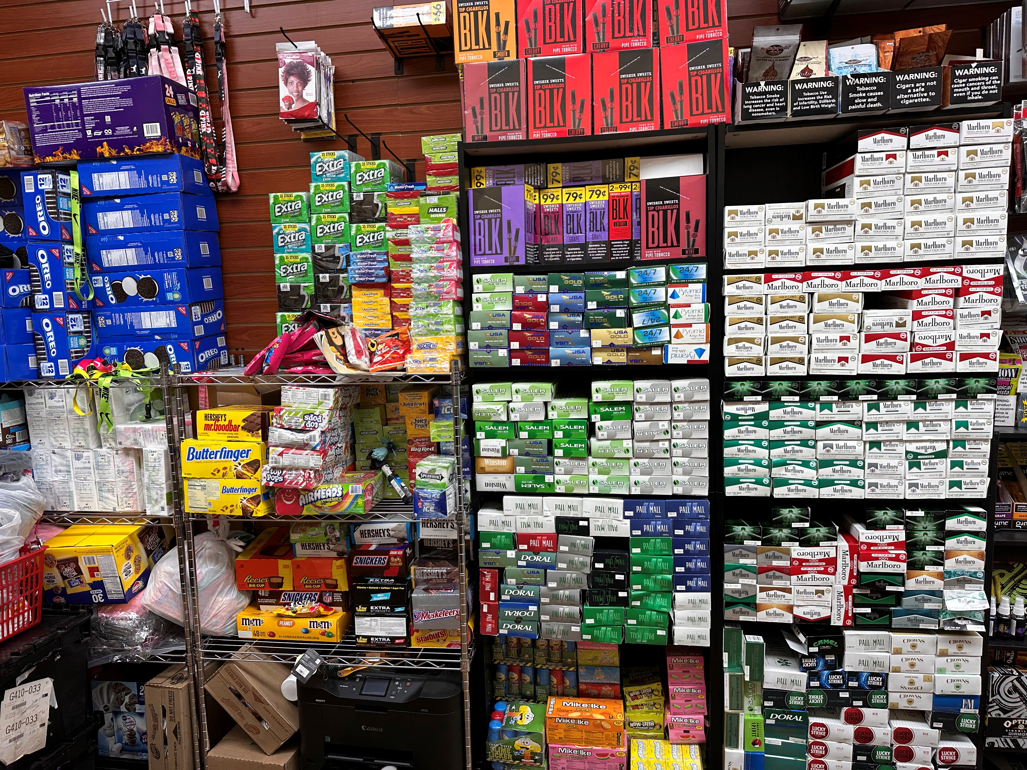

Figure 9.2 This picture is an actual gas station storeroom in which American and Spanish products are mixed and managed improperly. It makes it difficult for the worker to work and takes space for other important stocks. As well as the new stock dominating the old stock, the old stock is going back and the new stock is taking place in the front, and it makes it difficult for the employees to work most of the time they spend fixing the storeroom and sorting out which one to fix first in the shelf.

**Fig 9.2: Image of an actual gas station storeroom.**

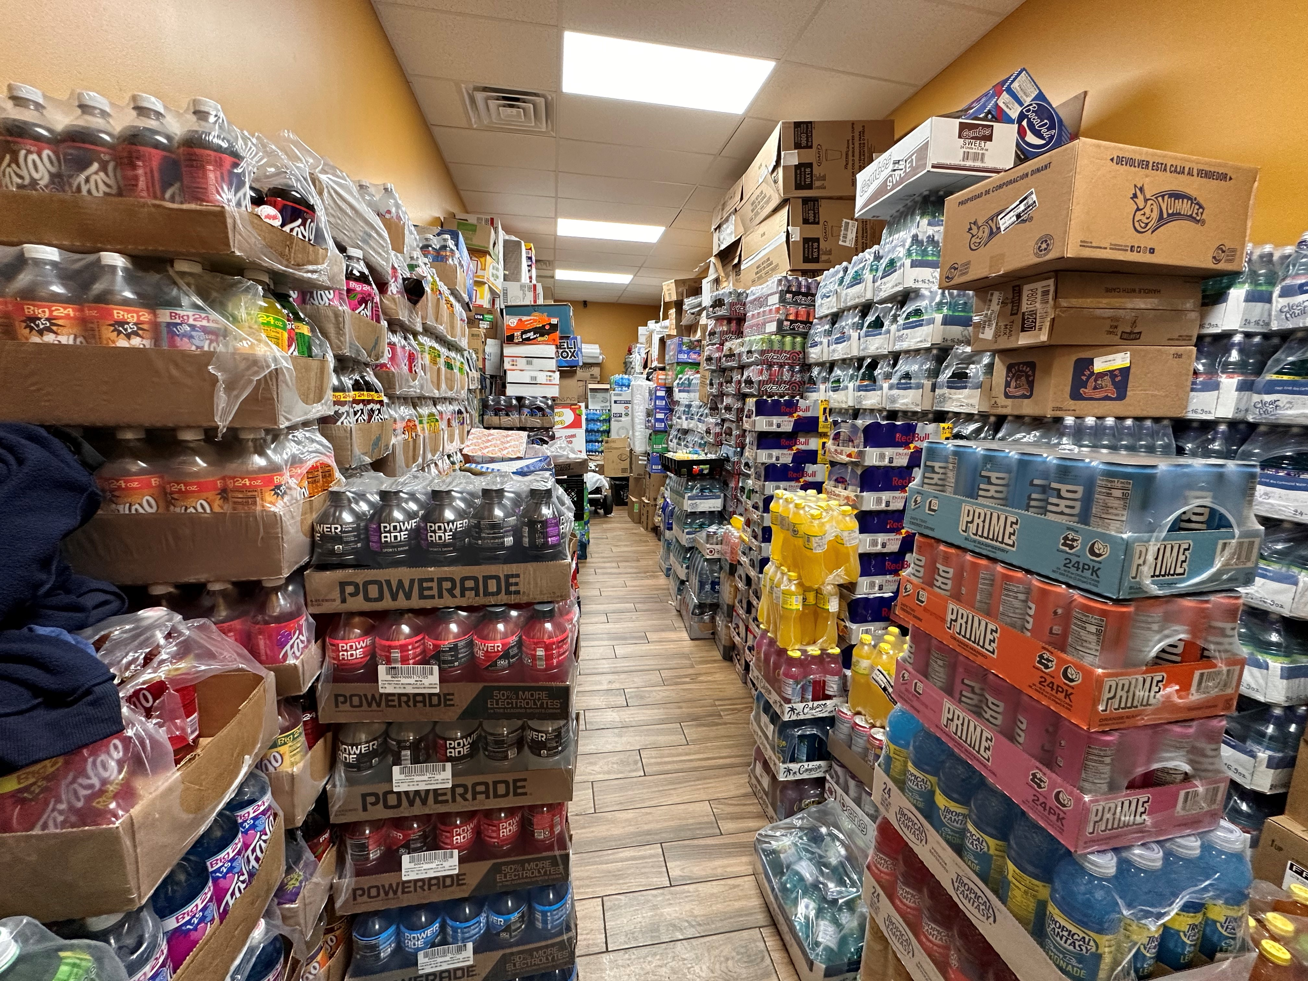

# 10) CONCLUSION:

To conclude, the Invoice and Inventory Management system is a simple web-based application initially suitable for small-scale business organizations. It has very basic tools which are used for small-scale business organizations for making this application. We have added products, generate invoices, pictures of the products, and stored data and the items as per the requirements.

IIMS is an essential part of the supply chain of any business. IIMS as a supply chain analysis is very essential in monitoring, planning, and managing the inventory or stocks of a small-scale organization. IIMS has many advantages ranging from cost, less time, and automatically generating invoices. It is necessary to have IIMS in business as they play a vital role in inventory management. IIMS has a technique for improving the efficiency of business to a higher standard for the organization.

By using a computerized system business work can be done in less time and in an efficient manner.

Nevertheless, in order to achieve high value for small-scale organizations & Higher success in the business, it is vital for those companies that use IIMS to follow a practice approach.

# 11) FUTURE IMPROVEMENTS:

In the future, we can increase more features for the betterment and effectiveness of the project as listed below:

* Adding Functionality to search for products.
* Home page design as per the user requirements.
* Making the system more flexible and convenient.
* Online payment system.
* Online billing system.
* Maintaining massive stocks.
* Return & Exchanges of the products.

# 12) REFERENCES:

1. <https://www.fastenal.com/fast/services-and-solutions/supply-chain-solutions?utm_campaign=SR_Inventory+Management&utm_source=google&utm_medium=ppc&utm_term=inventory%20management%20strategies&utm_content=3351122-e1-ng-mp-c15131998263-g132792432361-a591195309484-uCjwKCAjwiOCgBhAgEiwAjv5whPBvXmQTOBiJJCxSkIctrD79JtBunbvnmEmafwt_yIwVU5IyuF04kBoCOSgQAvD_BwE-cat10353022-kinventory%2520management%2520strategies-mod>.
2. <https://tier1mro.com/?gclid=CjwKCAjwiOCgBhAgEiwAjv5whJEn0Ef51R0xkDdz_6LNblSnoBA6YvfMDThXXJPaItkKdDJ3ccb59hoCX3kQAvD_BwE>.
3. <https://www.bing.com/search?q=lion+mart+east+raines&form=WSBEDG&qs=SW&cvid=a8643cb600d546f39de4632a2d7b5c9a&pq=lion+mart+east+raines&cc=US&setlang=en-US&PC=HCTS&nclid=8B1A770932D74C321FB357D8D97203F8&ts=1679452375818&wsso=Moderate>
4. <https://charlescparks.com/technology/>

# 13) APPENDIX:

# 13.1: APPENDIX (A) LIST OF FIGURES:

**Fig 6.2:** IIMS Process flow diagram

**Fig 8.1:** Home & Navigation bar coverage.

**Fig 8.2:** User sign-in form.

**Fig 8.3:** Add product details.

**Fig 8.4:** Add stock details.

**Fig 8.5:** View product list.

**Fig 8.6:** User/Admin changes the password.

**Fig 9.1:** Gas station stock excess Gummies, Candies, and cigars.

**Fig 9.2:** Image of an actual gas station storeroom.

# 13.2: APPENDIX (B) LIST OF Abbreviations:

IINM - Invoice & Inventory Management System.

AI - Artificial Intelligence.

HTML - Hyper Text Markup Language.

CSS - Cascading Style Sheets.

MySQL - My Structured Query Language.

IDE - Integrated Development Environment.